WEEKLY PROJECT REPORT
Project Title: AI-Based GST Compliance Helper for MSMEs using OCR and Automated Reconciliation
Role: Developer
Week: 4
Name: Bhoomika
SRN: R23EF048

1. Objectives for the Week
- To finalize system development and integrate all modules
- To implement chatbot functionality for GST assistance
- To improve system accuracy and performance
- To prepare the system for final demo and testing

2. Activities Performed
- Integrated OCR, reconciliation, and anomaly detection modules
- Implemented AI chatbot for GST assistance
- Optimized OCR and improved performance
- Enhanced dashboard and alert system UI
- Performed testing with multiple invoices
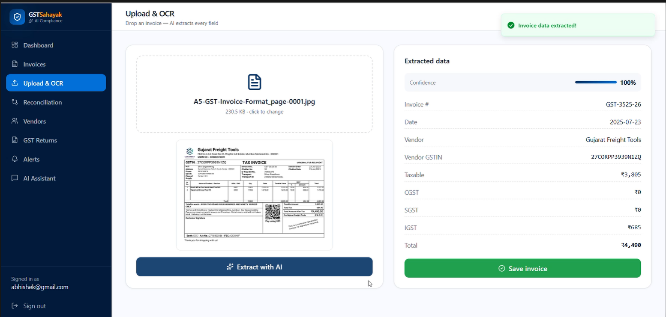

3. Key Design Decisions
- Integrated all modules into a unified workflow
- Focused on user-friendly design
- Used modular architecture
- Prioritized accuracy and performance

4. Contribution to Project Development
- Completed system integration
- Developed chatbot functionality
- Improved OCR and reconciliation
- Enhanced UI and usability
- Performed final testing

5. Challenges Faced
- Integrating multiple modules
- Handling OCR edge cases
- Ensuring chatbot accuracy
- Maintaining performance

6. Learning Outcomes
- Learned system integration
- Gained chatbot development experience
- Improved debugging skills
- Understood deployment challenges

7. Plan for Next Phase
- Integrate GST APIs
- Improve AI models
- Develop mobile version
- Add multilingual support

8. Conclusion
This week focused on finalizing and integrating all modules into a complete GST compliance solution.

